No. …./19
ISSN (online)
ISSN 2657-5841 (printed)
DOI: 10.26408/………

Title of the Manuscript
(Arial 12 point )

Author 1*, Author 2, Author 3 (Arial 10 point)
(The Authors’ names and their affiliation need to be included in the final manuscript/after acceptance of the paper to publish)

Affiliation for author 1, ORCID 0000-0000-0000-0000 (Arial 9 point)

Affiliation for author 2, ORCID 0000-0000-0000-0000

Affiliation for author 3, ORCID 0000-0000-0000-0000

*Corresponding author: current addresses, e-mail: author1@ssssss.ss

Abstract: Maximum 100–120 words. (ARIAL 9 point)
Keywords: Key points summarize the main points and conclusions of the article. Maximum
5 keywords or short phrases provided and separated with comma (,) that will assist indexers in cross-indexing the article. (ARIAL 9 point)
- INTRODUCTION (Arial 11 point)
Please use this template for preparing your manuscript as a proposal for acceptance and as an accepted final manuscript to publish in Scientific Journal of Gdynia Maritime University. Using this template and following the guidelines below, will help us expedite processing of your paper.
The manuscript can be prepared in Polish or English language. The author should provide WORD and PDF version of final manuscript.
The length of the paper contains 10–15 B5 pages (170 x 240 mm) including tables, figures, references and appendices (if any). Paper containing more than
15 pages will be returned to the author(s) to abridge. Articles should be written with single line spacing.
The author’s name, title, affiliation, address, telephone number, email address, abstract and titles of sections should be written in Arial. The paper body should be written in Times New Roman 11 point. For the rest please use our template (available here).
The main text should start with an introduction. An introduction can include background information such as theories, prior work, and hypotheses.
In the next sections the authors can include all other information, state-of-the-art, problem formulation, methods, results and finally conclusions.
Except for short manuscripts (such as comments and replies), the text should be divided into sections, each with its own heading. Sections are numbered (1, 2, 3, etc.). A maximum of four levels of heads may be used, with subsections numbered 1.1., 1.2.; 1.1.1., 1.2.1; 1.1.1.1., and so on. Headings should be sentence fragments. Examples of headings are:
- next Section (Arial 11 point)
The article should be divided into clearly defined and numbered sections (1, 2, 3, etc.). A maximum of two levels of heads may be used, with subsections numbered 1.1., 1.2., and so on. The first section is “Introduction” and the last one is “Conclusions”.
The second paragraph of the section ...
- next Section
Tables and figures must be included within the article, NOT at the end of the article. Maximum size of them (should be) 13 x 19 cm. They should not occupy more than one page each. Please note that the article will be published in black and white. Each table and figure should be numbered consecutively, titled and have source positioned below table and figure. All figures and tables should be cited in order. General and simple audience friendly graphs or tables are preferred. Titles and numbers should be positioned above the table and below the figure.
For initial submission, please embed figures, tables, and their captions within the main text near where they are cited.

Table 1. Title of table (ARIAL 9 point)
Heading
(ARIAL 8 point, bold)
Data (ARIAL, 8 point)
Source: own study.

Figures: line should be at least 0.5 pt wide, in at least 300 dpi resolution (additionally provided in a separate file, .tif or .jpg format).

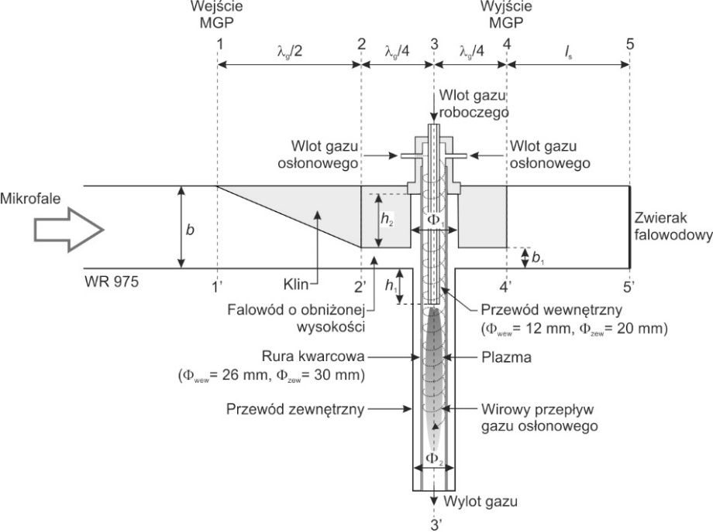
Rys. 1. Title of figure (ARIAL 9 point)
Source: [Thompson 2001].

- How to prepare references
Author(s) should use the Harvard style in referencing. Please visit https://www.usq.edu.au/library/referencing/harvard-agps-referencing-guide to learn more about Harvard style. Do not use footnotes.
4.1. Citations in the text (ARIAL, 10 point)
Please ensure that every reference cited in the text is also present in the reference list (and vice versa). Avoid citation in the abstract. Unpublished results and personal communications should not be in the reference list, but may be mentioned in the text [Carver 2001].
Citation of a reference as 'in press' implies that the item has been accepted for publication [Thompson 2005].
Recent research [Collins 1998; Brown 2001; Davies 2008] shows that…

4.2. Reference List
References should be arranged first alphabetically and then further sorted chronologically if necessary (TNR 9 point).

4.3. Examples

Reference to a book:
Tracy, B., 2011, Full Engagement!: Inspire, Motivate, and Bring out the Best in Your People, Amacom, New York.
Kakadia, D., DiMambro, F., 2004, Networking Concepts and Technology:
a Designer's Resource, Sun Microsystems Press, Upper Saddle River, New Jersey.
Brofenbrenner, U. (ed.), 2005, Making Human Beings Human: Bioecological Perspectives on Human Development, Sage Publications, Thousand Oaks, California.

Reference to a chapter in an edited book:
Callaghan, J., 2010, Singing Teaching as a Profession, in Harrison, S. (ed.), Perspectives on Teaching Singing: Australian Vocal Pedagogues Sing Their Stories, Australian Academic Press, Bowen Hills, Queensland.

Reference to a journal publication:
Wong, K., 2009, Rethinking the Hobbits of Indonesia, Scientific American, vol. 301, no. 5, pp. 66–73.
Thompson, G.M., 2005, Hotel Room Rates Across Booking Channels, Cornell Hotel and Restaurant Administration Quarterly, vol. 46, no. 2, pp. 106–107.

Reference to a web source:
McClain, M., Roth J.D., 1999, Schaum's quick guide to writing great essays, McGraw-Hill, New York, (17.01.2005),
http://ezproxy.usq.edu.au/login?url=http://site.ebrary.com/lib/unisouthernqld/Doc?id=5002145.
- Results

- Conclusions

- Acknowledgements

REFERENCES

Callaghan, J., 2010, Singing Teaching as a Profession, in Harrison, S. (ed.), Perspectives on Teaching Singing: Australian Vocal Pedagogues Sing Their Stories, Australian Academic Press, Bowen Hills, Queensland. (TNR, 9 POINT).

Flexer, R.W., Baer, R.M., Luft, P., Simmons, T.J., 2008, Transition Planning for Secondary Students with Disabilities, 3rd ed., Pearson, Upper Saddle River, New Jersey.

Goldsworthy, J., 2010, Parliamentary Sovereignty: Contemporary Debates, Cambridge Studies in Constitutional Law, Cambridge University Press, Cambridge.

McClain, M., Roth J.D., 1999, Schaum's Quick Guide to Writing Great Essays, McGraw-Hill, New York, (17.01.2005),
http://ezproxy.usq.edu.au/login?url=http://site.ebrary.com/lib/unisouthernqld/Doc?id=5002145.

